SMART AGRICULTURE AND STORAGE

SYSTEM

Monu Singh Rajan Kumar Sah

CSE,*MSRIT* CSE,*MSRIT*

Bangalore,india Bangalore ,india

monusingh@gmail.com rajansah0020@gmail.com

Vikash Bajoria Yogesh Manglekar

CSE,*MSRIT* CSE,*MSRIT*

Bangalore ,india Bangalore,india

vikashbajoria957@gmail.com yogessh.sayes@gmail.com

Keywords: Cloud computing,Noobs,python

**Abstract**

Use of technology in different areas to get various benefits in itself research of big area. Use of sensor in the agriculture is not a new trend. The use of technology to benefit the agriculture is always a encouraging thing for human being. There is a lot of environmental condition which affect the crop and its production. So we thought we should come with a unique idea of making use of current available technology to bring some major change in how agriculture sector is working these days. This is just a small effort to make innovative and smart agriculture system.

In this chapter ,the concept of smart agriculture and storage system is described and use of different advanced technology towards agriculture sector is highlighted. The evolution of different advanced technology is also presented. Some details about the development of smart agriculture[1] prototype for irrigation control and trepassing the part of this chapter.

**i.Introduction**

Different areas of life are getting a great impact by the advancement in technology .People are working towards the automation with some level of intelligence to replace or minimize the human factor from the process. people are relying more on devices and they are trying to make their life more comfortable and easy.

Now-a-days everything is termed as smart and exactly what does smart means. Smart means working towards developing the autonomous system that could take some level of decision by their own in different levels of simple circumstances. And in this race of make everything more modern, somewhere agriculture has been left behind and especially we could see very less organization is working towards making agriculture modernised and i think we should do something innovative for them and here we are with this unique way to help farmer to grow their crop and its storage. We often see a thousand tons of crops gets destroyed in godown which could have been food for thousand of poor people and i think using the help of modern technology we could help people in saving the crop so the farmer could get what they deserve for and a lot of money could be saved.

Major problem faced by farmer in agriculture and storage of crops due to climate change.[2] The damage to the crop stored in storage room cost them a lot and thus they could not get the money what they deserve for. Also the crop residual material which could also be used as fuel got damaged and become useless. So we are coming up with the unique solution which will help farmer to prevent and reduce the damage. This system will notify farmer about the situation of the storage facility room. The Motion detector will give them information of any intruder trepassing the property. Sometime cattle enter the crop destroy all of it so motion detector[3] will help in inform farmer about it so that he/she could prevent it. Also the motion detector will detect presence of anyone near or in storage facility room. The farmer does not know the exact pattern of rainfall and they water the field and sometime does not water it so due to excessive or shortage of water in soil crop get affected. We are using soil moisture detector[4] to measure presence of moisture in soil and thus farmer could take the measure. Smart Agriculture could be defined as “an approach to understand the requirement as well as change in current environment.

Smart agriculture is based on following steps:

1.Sensing local environment data

2.Identification of sensing data.

3.transferring data from crop field and storage facility to

Control decision making.

4.Decision making based on local data, domain knowledge and history of record.

5.Actuation and control based on decision.

The concept of smart agriculture and storage facility is based on integration of well known technology that are sensor network technology, cloud computing[5] etc.

The Raspberry Pi is a series of credit card–sized single-board computers.  include the same VideoCore  IV GPU and either a single-core ARMv6 compatible CPU or a newer ARMv7-compatible quad-core one (in Pi 2); and 1 GB of RAM (in Pi 2), 512 MB or 256 MB (in older models A and A+). They have Secure Digital (SD) (models A and B) or MicroSD (models A+ and B+) sockets for boot media and persistent storage.[[](https://en.wikipedia.org/wiki/Raspberry_Pi#cite_note-VerifiedPeripheralList-12)  they can be connected to a network using an external user-supplied USB Ethernet or Wi-Fi.We are using it as device which interact with all the devices and send the data to the cloud.It is intermediate between actuator and sensor.

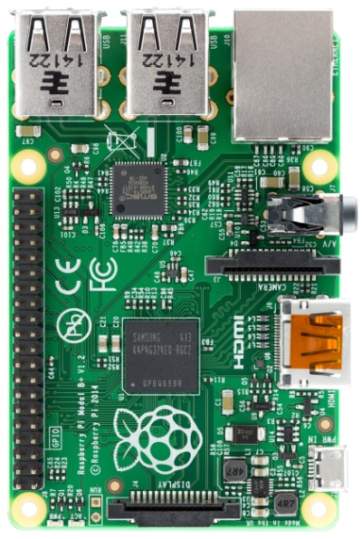

Fig1.0 Raspberry pi

The motion sensor detects the presence of human being in the range of 15 m and send the data to the cloud which is further being notified.

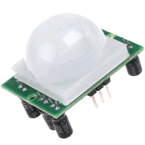 Fig1.1 motion detector

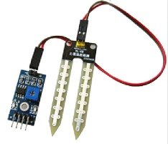

Fig1.2 Soil moisture Sensor

We are using humidity sensor[7] and temperature sensor[8] to get the information about the environment and if the environment condition is not good for stored grain ,it notify the farmer and so that he could take some measure.

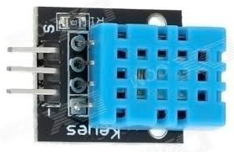

Fig1.3 Dth11

**II.DESIGN**

This project has three sensor as its component. Raspberry pi[9] is being used to read data from sensor and for the implementation of the project. The concept of storing data using cloud platform is being used to store data of sensor from cloud and send the data to email[9] so that it could be analysed and used by the user.

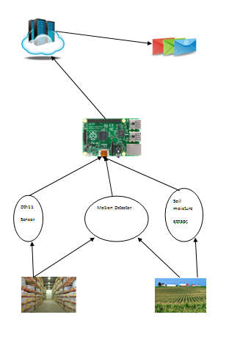

Fig2.1 Design of the project

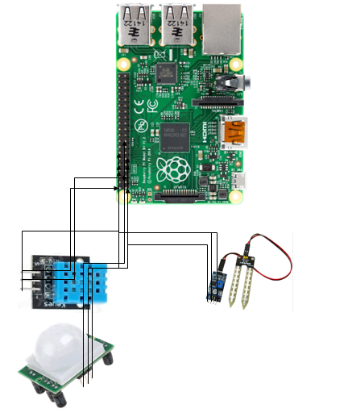

Fig2.2 Circuit diagram

The Dth11 send temperature and humidity sensor to the raspberry pi..The motion detector detect the presence of the human being and send data, which is further send to cloud and after analysing the data, user is being notified if it is necessary.

**III.IMPLEMENTATION**

I)Code to connect to cloud server and send it

import RPi.GPIO as GPIO

import dht11

import time

from ubidots import ApiClient

# initialize GPIO

GPIO.setwarnings(False)

GPIO.setmode(GPIO.BOARD)

GPIO.cleanup()

GPIO.setup(19,GPIO.IN)

GPIO.setup(7,GPIO.IN)

GPIO.setup(8,GPIO.IN)

#Create an "API" object

api = ApiClient("f0aee71e9c7d1ca8e792c1b39cb90448d734d76c")

#Create a "Variable" object

test_variable = api.get_variable("5669177d76254278e8150f21")

test1_variable = api.get_variable("56695d66762542112ed97c2b")

test2_variable = api.get_variable("56695d56762542128eb5dbfb")

test3_variable = api.get_variable("566973c876254243f3602899")

# read data using pin 14

instance = dht11.DHT11(pin = 8)

result = instance.read()

result1= GPIO.input(19)

time.sleep(0.1)

current_state = GPIO.input(7)

if result.is_valid():

test_variable.save_value({'value':result.temperature})

test2_variable.save_value({'value':result.humidity})

test1_variable.save_value({'value':result1})

test3_variable.save_value({'value':current_state})

else:

print("Error: %d" % result.error_code)

II)Dth11[10]

import time

import RPi.GPIO as GPIO

class DHT11Result:

DHT11 sensor result returned by DHT11.read() method'

ERR_NO_ERROR = 0

ERR_MISSING_DATA = 1

ERR_CRC = 2

error_code = ERR_NO_ERROR

temperature = -1

humidity = -1

class DHT11:

'DHT11 sensor reader class for Raspberry'

__pin = 0

def __init__(self, pin):

def read(self):

GPIO.setup(self.__pin, GPIO.OUT)

self.__send_and_sleep(GPIO.HIGH, 0.05)

self.__send_and_sleep(GPIO.LOW, 0.02)

GPIO.setup(self.__pin, GPIO.IN, GPIO.PUD_UP)

data = self.__collect_input()

pull_up_lengths = self.__parse_data_pull_up_lengths(data)

if len(pull_up_lengths) != 40:

return DHT11Result(DHT11Result.ERR_MISSING_DATA, 0, 0)

bits = self.__calculate_bits(pull_up_lengths)

the_bytes = self.__bits_to_bytes(bits)

checksum = self.__calculate_checksum(the_bytes)

if the_bytes[4] != checksum:

return DHT11Result(DHT11Result.ERR_CRC, 0, 0)

return DHT11Result(DHT11Result.ERR_NO_ERROR, the_bytes[2], the_bytes[0])

unchanged_count = 0

max_unchanged_count = 100

last = -1

data = []

while True:

current = GPIO.input(self.__pin)

data.append(current)

if last != current:

unchanged_count = 0

last = current

else:

unchanged_count += 1

if unchanged_count > max_unchanged_count:

break

return data

lengths = []

current_length = 0

for i in range(len(data)):

current = data[i]

current_length += 1

if state == STATE_INIT_PULL_DOWN:

if current == GPIO.LOW:

state = STATE_INIT_PULL_UP

continue

else:

continue

for i in range(0, len(pull_up_lengths)):

length = pull_up_lengths[i]

if length < shortest_pull_up:

shortest_pull_up = length

if length > longest_pull_up:

longest_pull_up = length

halfway = shortest_pull_up + (longest_pull_up - shortest_pull_up) / 2

bits = []

for i in range(0, len(pull_up_lengths)):

bit = False

if pull_up_lengths[i] > halfway:

bit = True

bits.append(bit)

return bits

for i in range(0, len(bits)):

byte = byte << 1

if (bits[i])

byte = byte | 1

else:

byte = byte | 0

if ((i + 1) % 8 == 0):

the_bytes.append(byte)

byte = 0

return the_bytes

**IV.RESULT**

a)If the temperature is greater than 15,it will notify user to act.

b)If the humidity is greater than 83%,it will notify user to act.

c)If there is presence of human near storage facility and near crop ,it will send email to the user.

d)If there is presence of moisture in the soil, email will be sent to the user if they should water the crop or not.

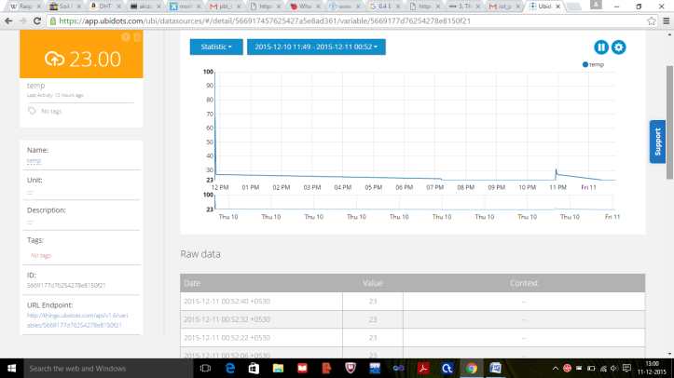

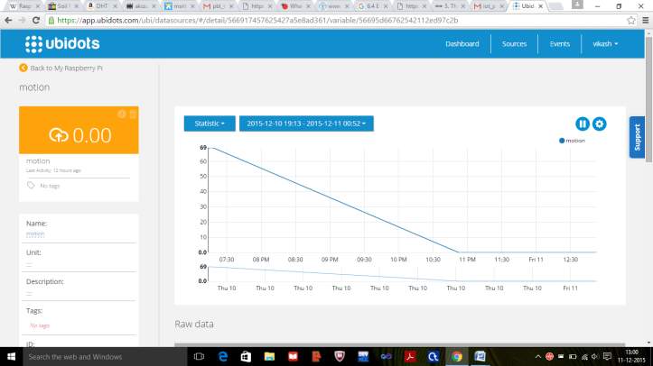

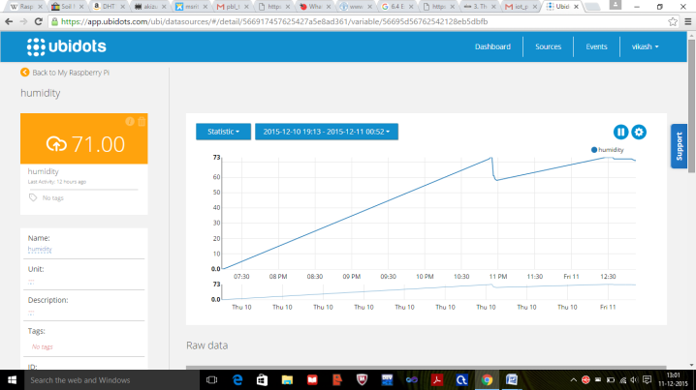

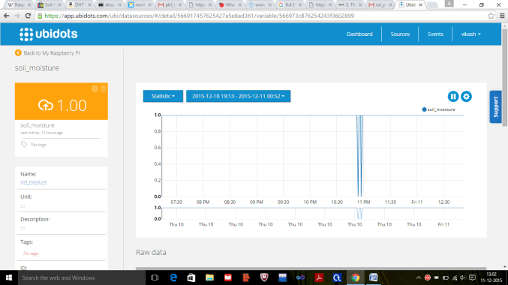

**V.SCOPE AND FUTURE WORK**

As this project is about analysing data which deals with agriculture, it has got great scope. It would help farmer who could not help himself in many situation and this project is all about eliminating all these problem and giving them the simple and easy way to prevent this situation. As india has 50% of farmer so i think it would benefit country in a greater and efficient way and which would ultimately help in development of country. This project will increase the yield of the production and thus the a large quantity of the crop stored could be prevented from rotting. Also the power consumption for maintain temperature in the storage facility would decrease as the farmer would know when to use the machine to maintain appropriate condition.

The project could be extended for further use. We could use the idea of automation of the water motor which will start functioning when the percentage of humidity in the soil is below the critical point and it will stop watering if the percentage go beyond the certain limit .We could use something to distract animal and human from crop field. The cooling machine installed in storage house could start functioning and stop functioning if the environmental condition go beyond it. We could also use some sensor to read the data of pesticides and could control the The farmer could control the crop and storage facility just by sitting at his doorstep and which would make their life more comfortable and prosperous.

**VI.CONCLUSION**

We concluded that how using technology could solve the real life problem of the people in much efficient and better way. How technology has made the life of human being so easy and how it could eliminate problem of the people, society and any other organization. So such an idea could change the scenario of the society and the people and it has become integral part of the human world.

**ACKNOWLEDGEMENT**

We cordially thank our respected HOD Sir,Dr. K. G. Srinivasa for assisting us in presenting this paper and giving us the opportunity to work on some real life problem..We thank our department faculty who provided insight and expertise that greatly assisted and motivated us.

We would also like to show our gratitude to our respected teacher Dr.Anita Kanavalli,  Mrs.Sowmya B. J for sharing their pearls of wisdom with us during the course of this project work.

We are also immensely grateful to our family without whose blessing it could not had been possible.

**REFERENCES**

[1].http://www.thingworx.com/Markets/Smart-Agriculture

[2].https://en.wikipedia.org/wiki/Climate_change_and_agriculture

[3]. https://en.wikipedia.org/wiki/Motion_detector

[4]. https://www.sparkfun.com/products/13322

[5].http://searchcloudcomputing.techtarget.com/definition/cloud-computing

[6]http://www.engineersgarage.com/articles/humidity-sensor

[7] http://www.electronics-tutorials.ws/io/io_3.html

[8] https://www.raspberrypi.org

[9] https://www.google.co.in/#q=email

[10]http://www.instructables.com/id/How-to-interface-Humidity-and-Temperature-DTH11-Se